Normal Distribution Examples

Calculating Probabilities
Question 1.
Find $P\left(X<1\right)$ to 4 decimal places.
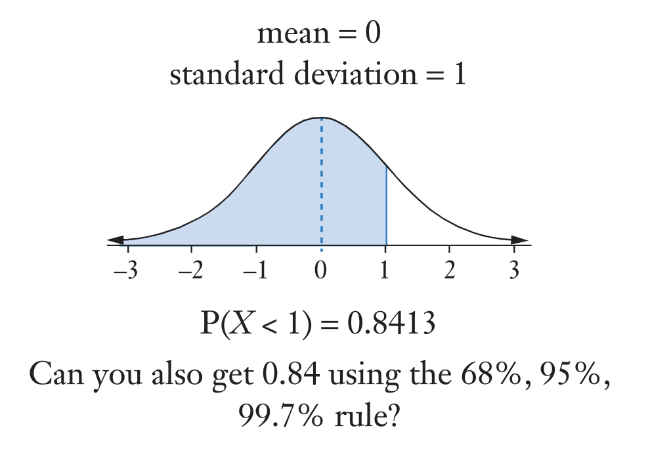

Using Classpad:

- From Menu, click on the “Statistics” app


- Click Calc > Distribution



- Select “Normal CD” from the second drop down menu



- Enter the lower boundary, upper boundary, mean and standard deviation then click “Next”



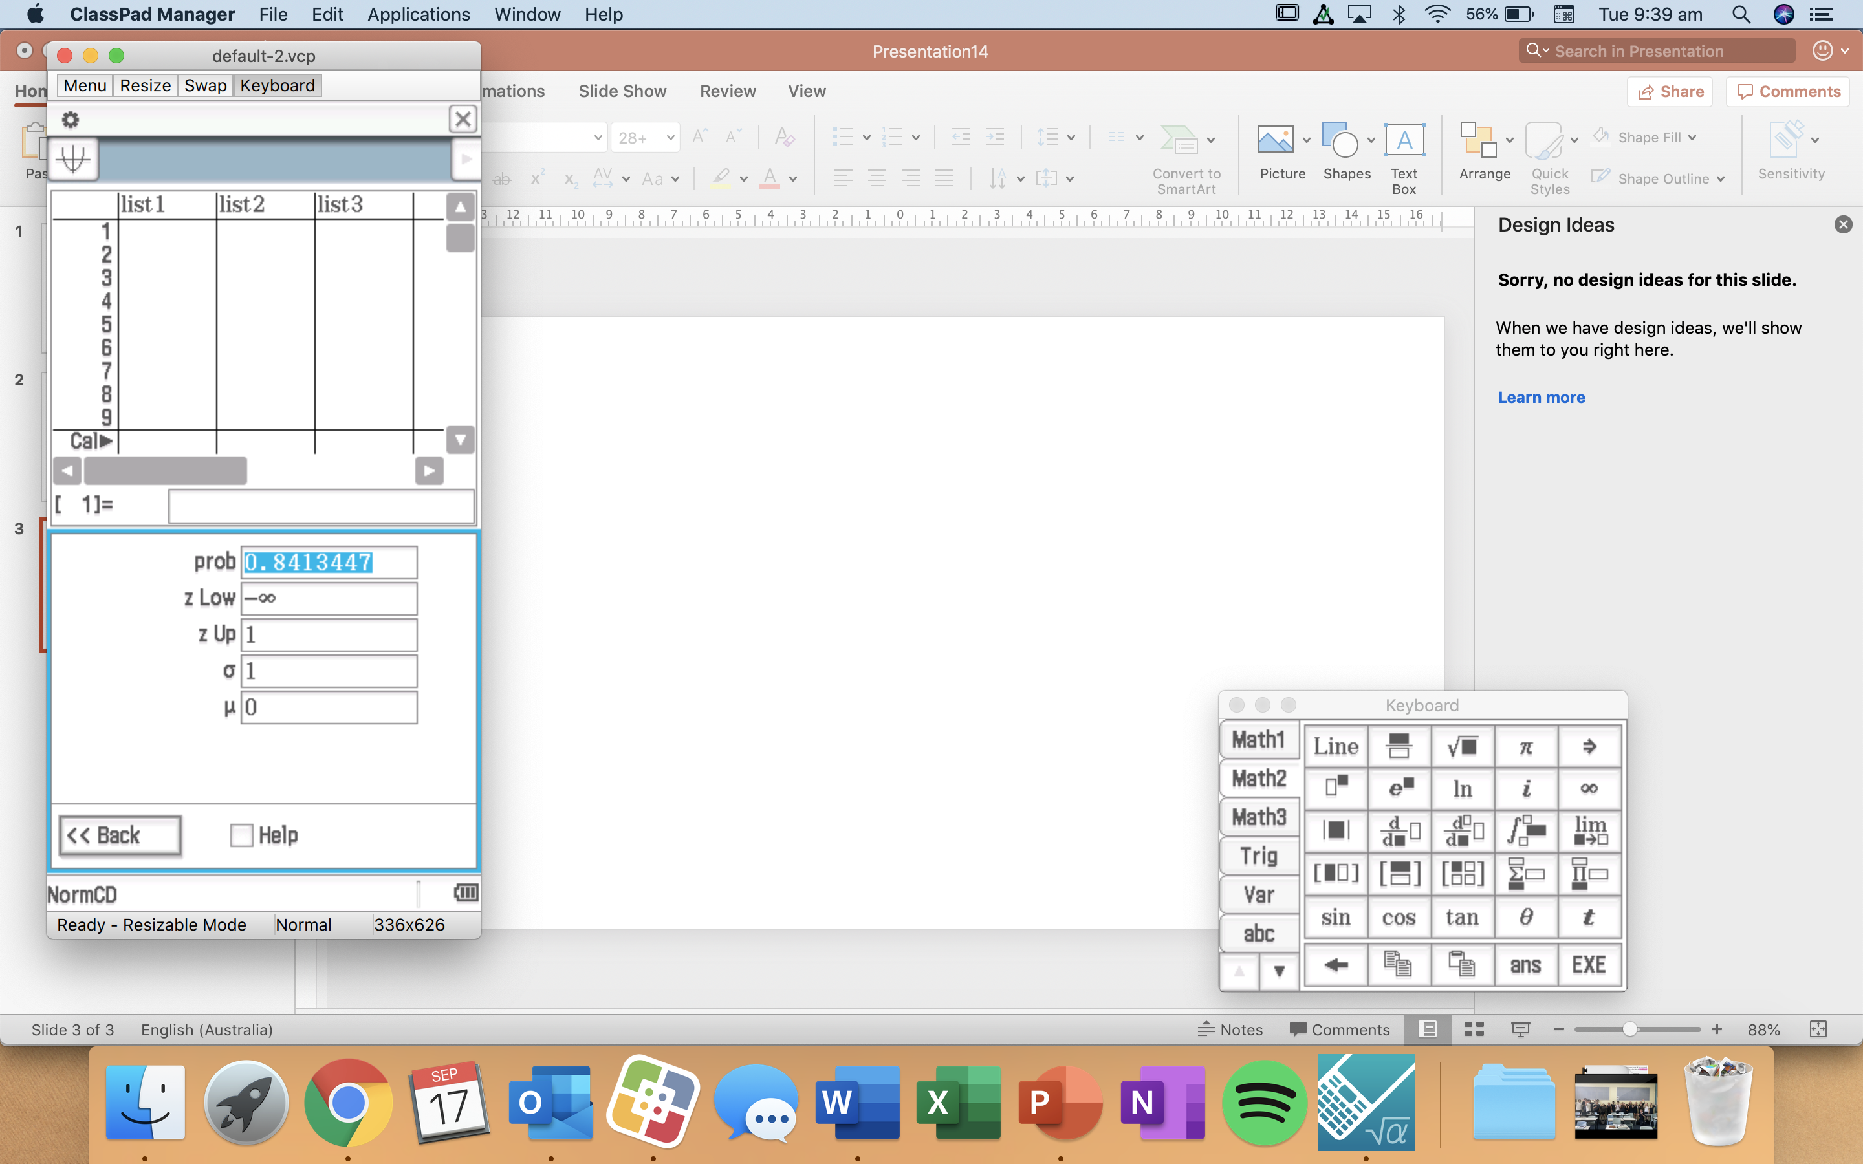

Hence, when $μ=0$ and $σ=1,$ $P\left(X<1\right)=0.8413$(4 d.p.).

By hand (using the 68.3, 95.4, 99.7% rule):
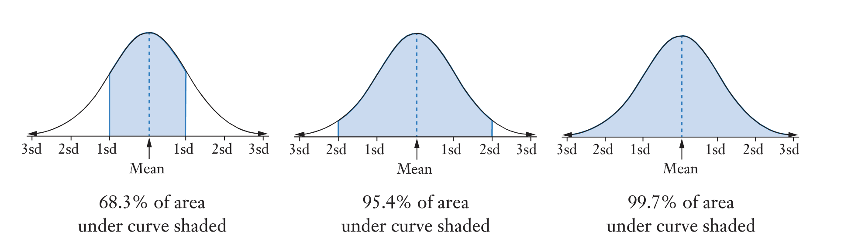

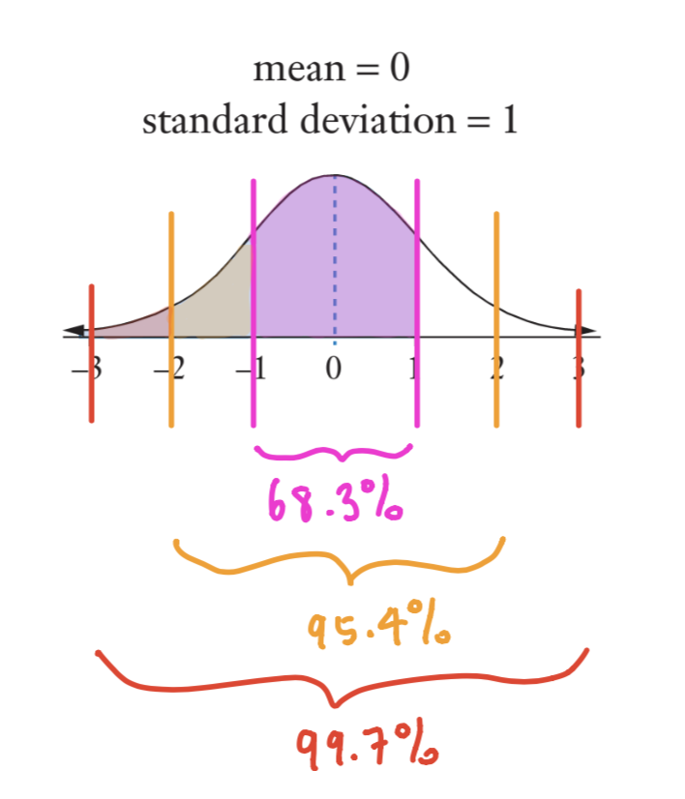

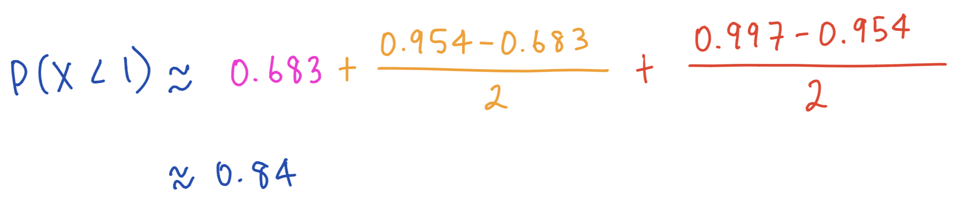

Calculating boundaries given a probability:

Question 2.
Find $k$ given that $P\left(X>k\right)=0.9656$.
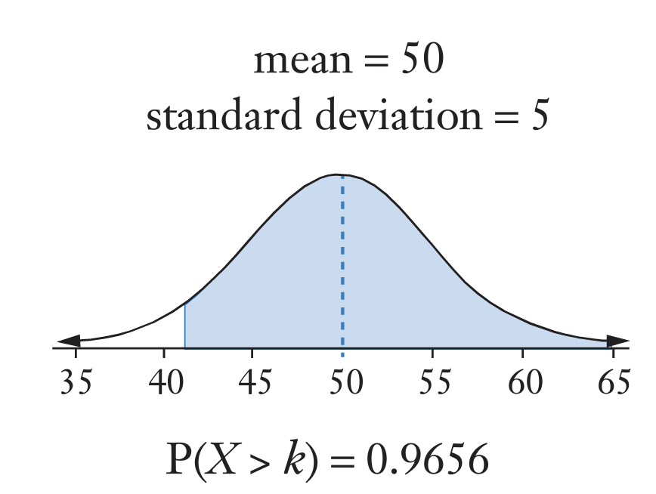

- From Menu, click on the “Statistics” app


- Click Calc > Inv. Distribution

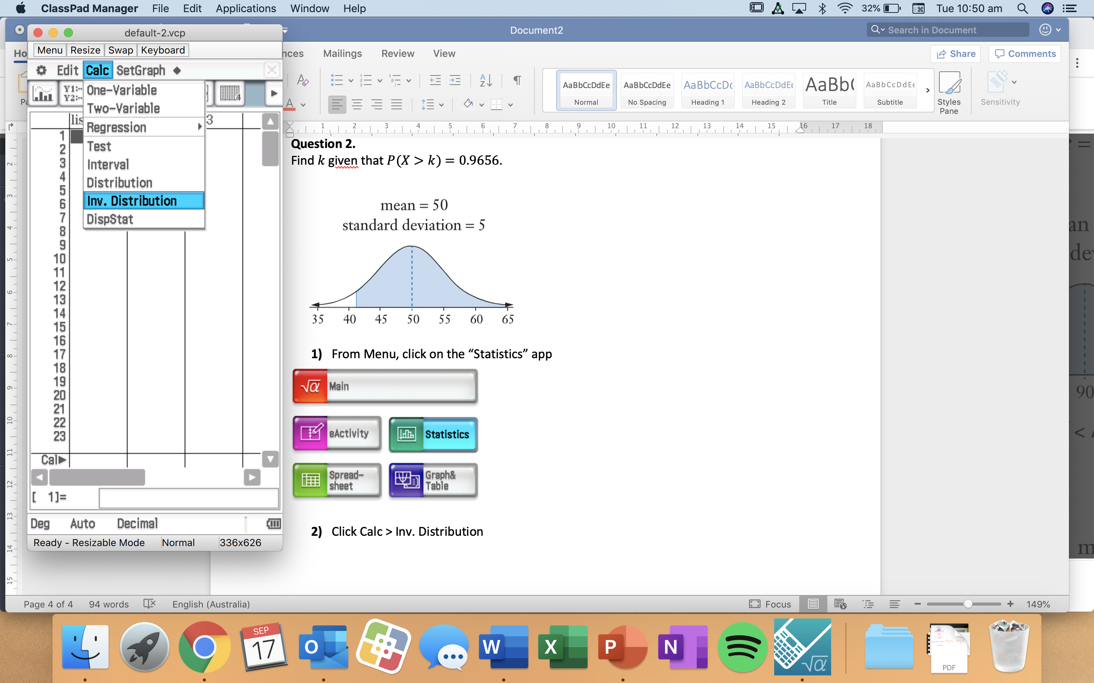

- Make sure “Inverse Normal CD” is selected then click “Next”

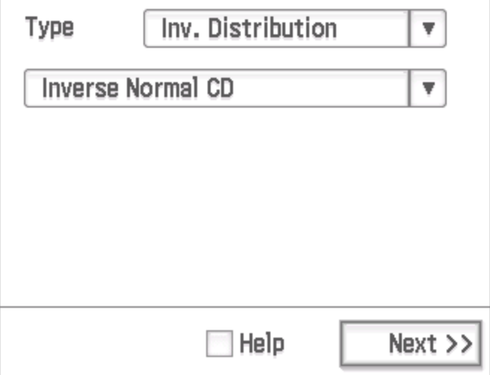

- For this question, the probability given includes the right tail of the graph so change the tail setting to “Right”, enter the probability, mean, and standard deviation then click “Next”.

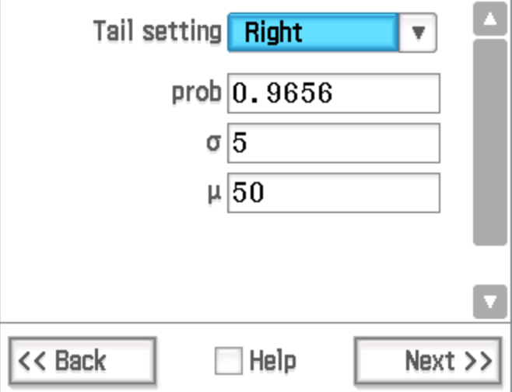



Hence, $k=40.9$ (1 d.p.).

i.e. When $μ=50$ and $σ=5,$ $P\left(X>40.9\right)=0.9656$.

Question 3.
Find $k$ given that $P\left(-1.4<X<k\right)=0.7215$.
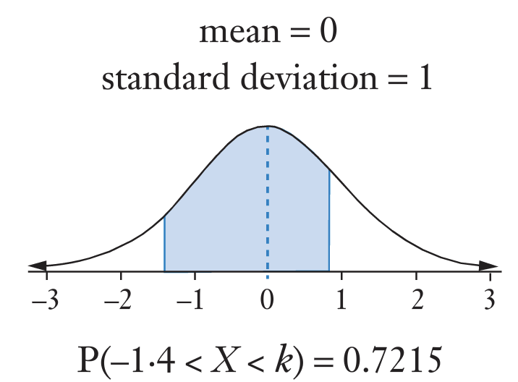

- From Menu, click on the “Statistics” app


- For this question, we cannot use the tail setting “Centre” because the shaded area isn’t centred about the mean. We also cannot use “Left” or “Right” because the area shaded includes neither the left nor right tail.

We can however create a “left tail” by calculating $P(X<-1.4)$ then adding it to the shaded area.

In Statistics, click Calc > Distribution, select “Normal CD” from the second drop down menu, click “Next”, enter the lower boundary, upper boundary





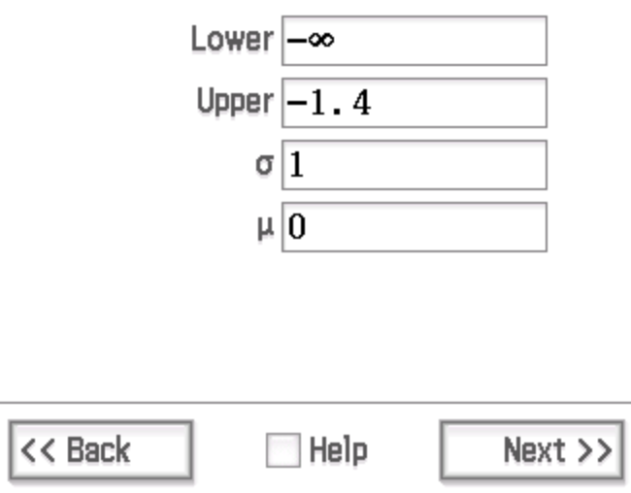

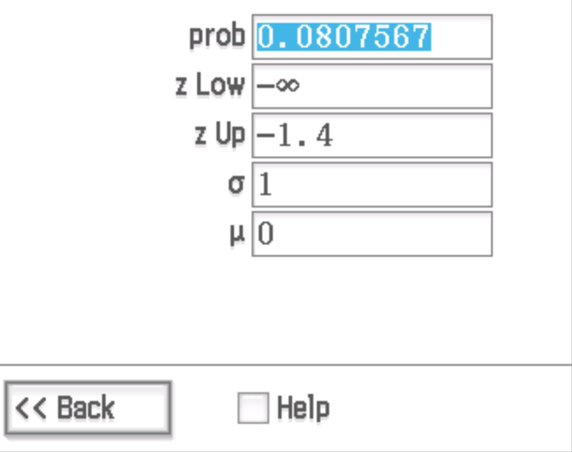

Hence $P\left(X<-1.4\right)=0.0807567$

$P\left(X<k\right)=P\left(X<-1.4\right)+P\left(-1.4<X<k\right)$
$P\left(X<k\right)=0.0807567+0.7215$
$P\left(X<k\right)=0.8022567$

- Click Calc > Inv. Distribution, select “Inverse Normal CD” then click “Next”




Enter the tail setting, probability, mean and standard deviation then click “Next”. In this case, we created a “left tail” and the new probability is $0.8022567$.

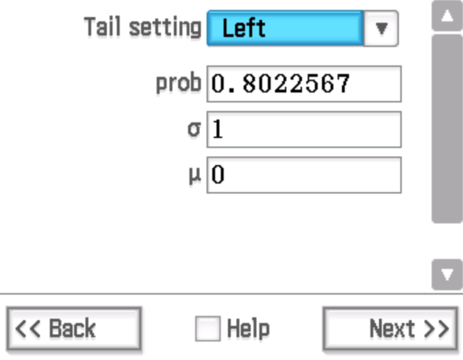

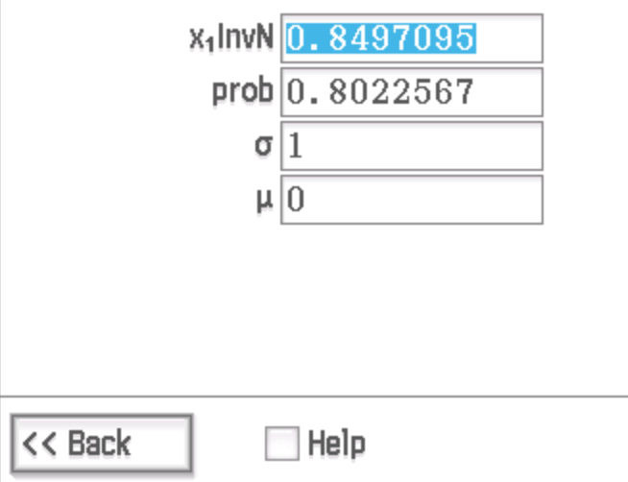

Hence, $k=0.85$ (2 d.p.).

i.e. When $μ=0$ and $σ=1,$ $P\left(-1.4<X<0.85\right)=0.7215$.

